**Module 2 Kinematics of particles**

**Relative Motion**

1. Figure below shows cars A and B at a distance of 35 m. Car A moves with a constant speed of 36 KPH and car B starts from rest with an acceleration of 1.5 m/s². Determine relative (I) position (ii) velocity (iii) acceleration of car B with respect to car A five seconds after car A crosses the intersection.

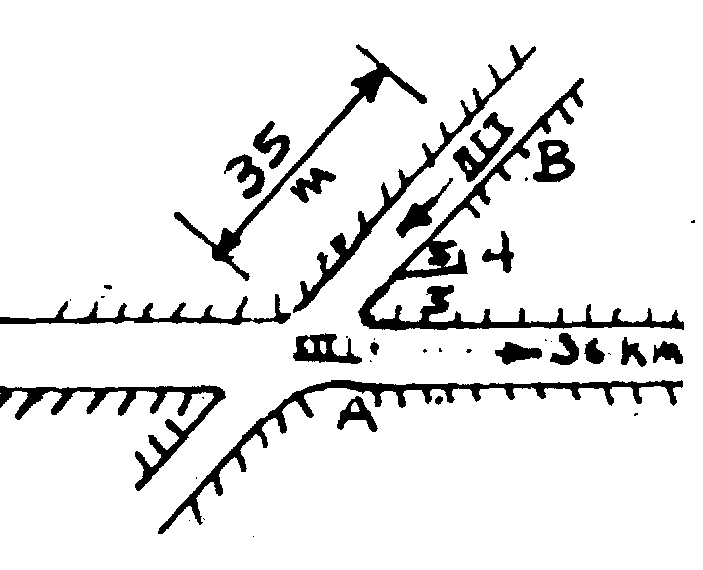

2. Figure shows two cars A and B at a distance of 35m. Car A is traveling east at a constant speed of 36 KPH. Car B starts from rest and moves south with a constant acceleration of 1.2 m/s². Determine the (1) position (ii) velocity and (iii) acceleration of car B relative to car A six seconds after car A crosses the intersection of roads.

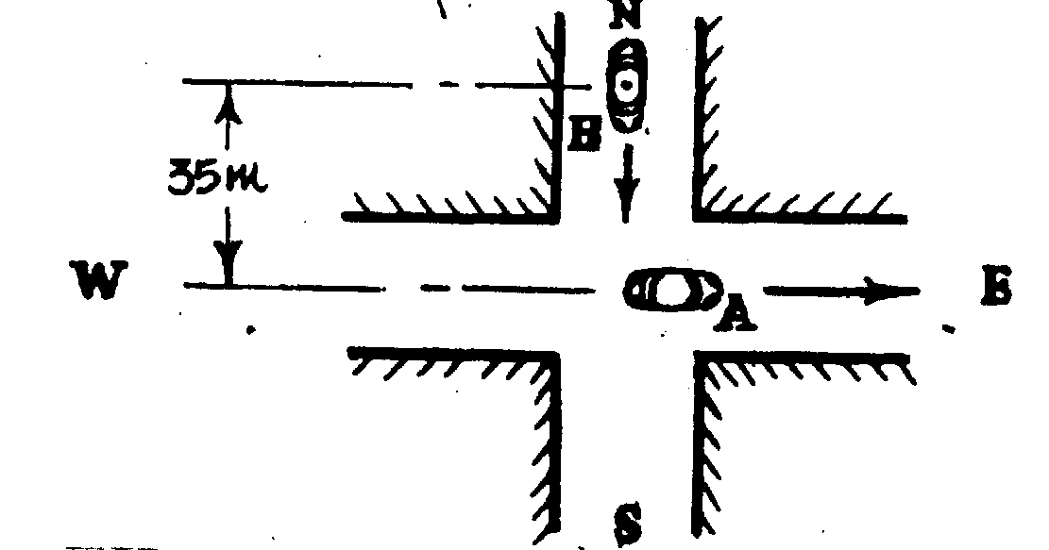

3. A jet of water is discharged at A with a velocity of 20 m/s to strike a moving plate B as shown in the figure. If the plate is moving downwards with a velocity of 1 m/s Determine the relative velocity of water w.r.t. the plate just before it strikes.

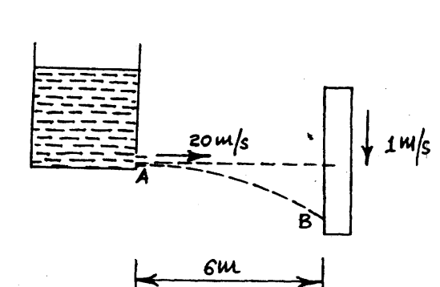

4. At t = 0 wedge A starts moving to the right with constant acceleration of 122 mm/s² and block B starts moving along the wedge towards left with constant acceleration of 135 mm/s² relative to the wedge. Determine (1) Acceleration of B (2) Velocity of B at t = 5 sec.

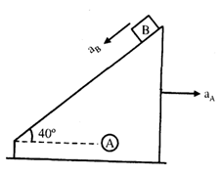

5. When a cyclist is riding at 12 KPH he finds the rain meeting him at an angle of 45º with the vertical. When he rides at 8 KPH, he finds the rain meeting him at an angle of 30º with the vertical. What is the actual velocity (magnitude and direction) of the rain’?

6. Two ships leave a port at the same time. One steams North at 20 KPH and the other streams East at 15 KPH Find:

i) the speed of the second relative to the first,

ii) the time after which they will be 100 km apart.

7. Two trains whose lengths are 75 m and 45 m respectively are moving in opposite direction Parallel tracks and are observed to take 4 seconds in completely crossing each other. If the shorter train is traveling at double the speed of the longer, find the speed of each.

8. Find the absolute velocity and acceleration of the block “3” at the instant shown. Also find the relative velocity and relative acceleration of block “1” with respect to block “3”

Given: V1 = 2 m/s (↑), V2 = 3 m/s (↓) ,a1 = 1 m/s² (↓) ,a2 = 2 m/s² (↑).

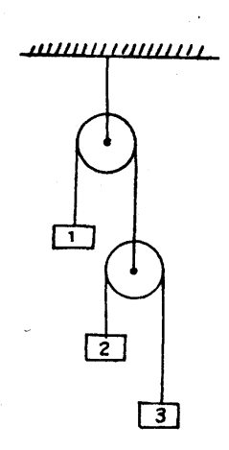

9. Automobile A is traveling along a straight highway, while B is moving along a circular curve of 150 m radius. The speed of A is increased at the rate of 1.5 m/s² and the speed at B is being decreased at the rate of 0.9 mIs². For the position shown in figure, determine the velocity of A relative to B and the acceleration of A relative to B. At this instant the speed of A is 75 KPH and that of B is 40 KPH.

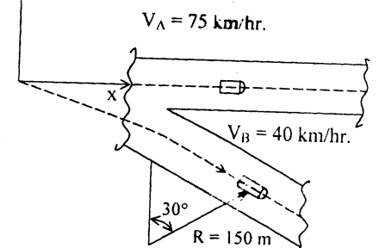

10. Three blocks shown in the figure move with constant velocities. Find the velocity of each block knowing that the relative velocity of A w.r.t. C is 300 mm/s upwards and that the relative velocity of B w.r.t. A is 200 mm/s downwards.

